**7: MAP COLORING**

1. **Modeling a map by a graph**

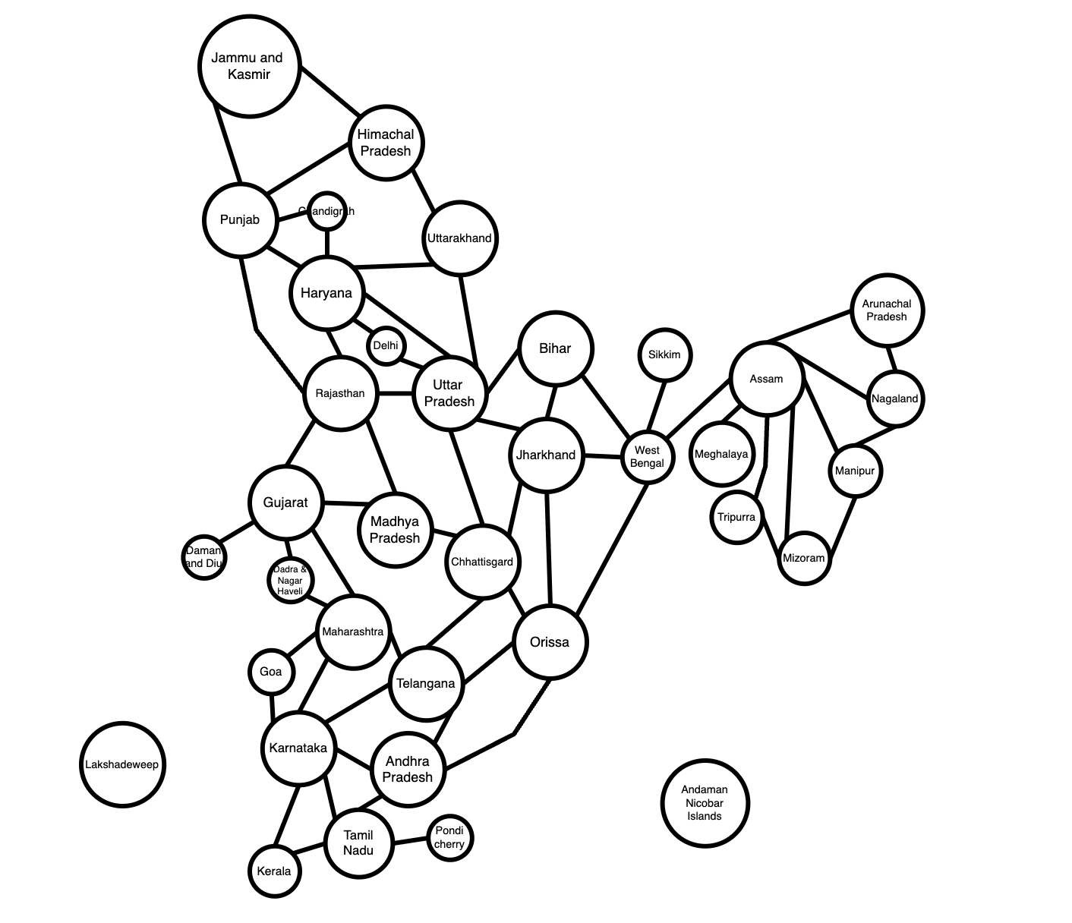

1. **Color the map (graph) with a minimum number of colors. Present your solution step by step.**

Let abcd be the 4-digit number combined by the last 4 digits in your StudentID*.* Our StudentID is 22H0024 so has abcd = 0024

24 % 4 = 0 so start from Bihar.

In this question we use 4 color to color the map.

#1:

#2:

#3:

#4:

To color the map with a minimum number of colors, we use Greedy coloring algorithm:

We start with the first node from Bihar. We use the first color is red.

Step by step color:

**Step 1:** We color the node that not the neighbors of each other.

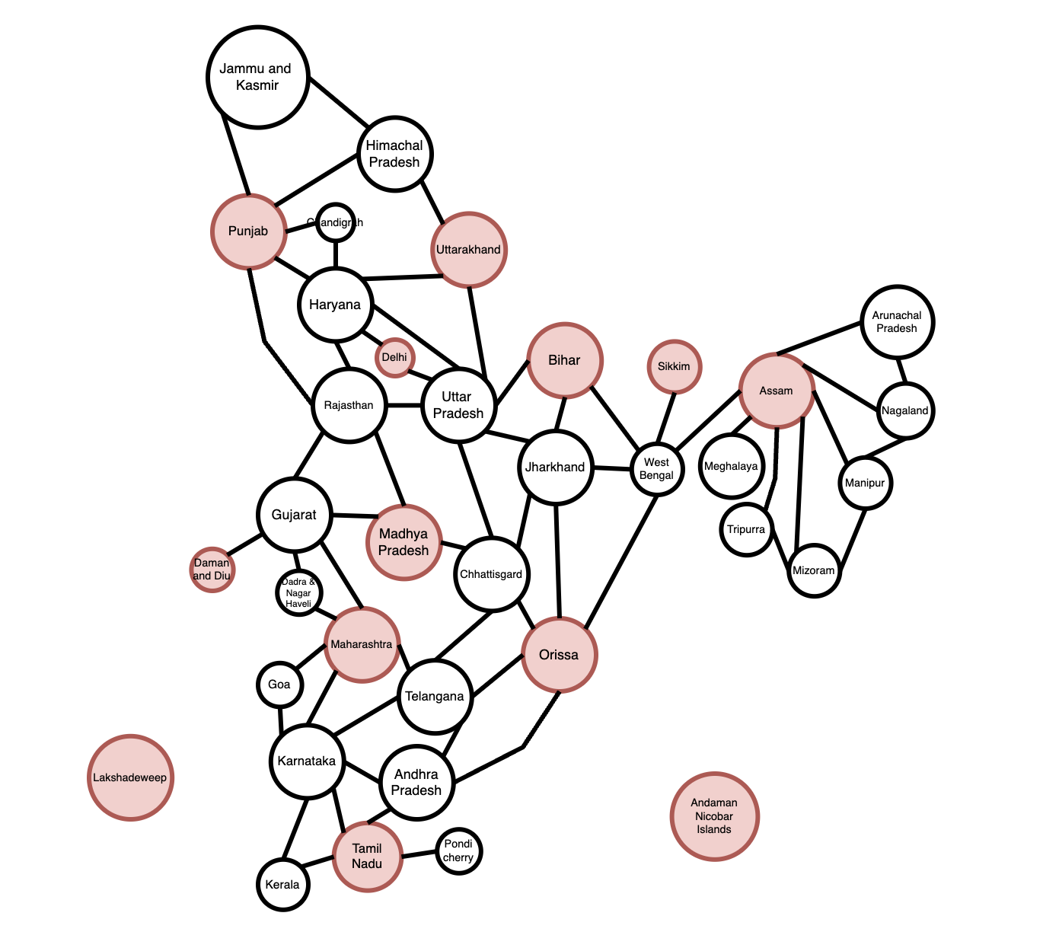

**Step 2:** Eliminated the colored nodes, then we use the second colors is green to color the node. Start from the Bihar’s neighbor node.

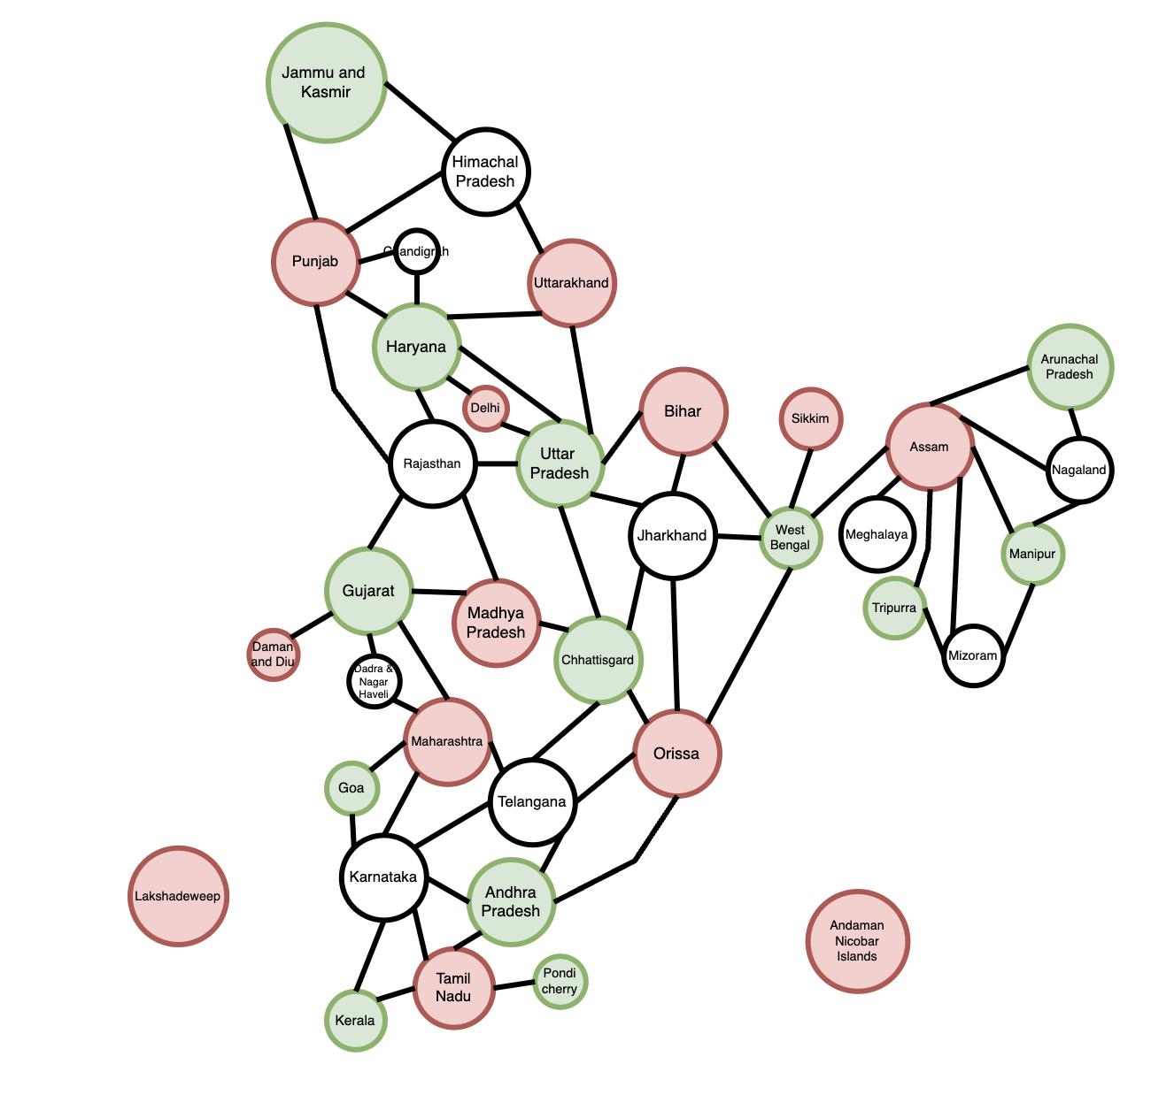

**Step 3:** Eliminated the colored nodes, then we use the third colors is yellow to color the node. Start from Jharkhand.

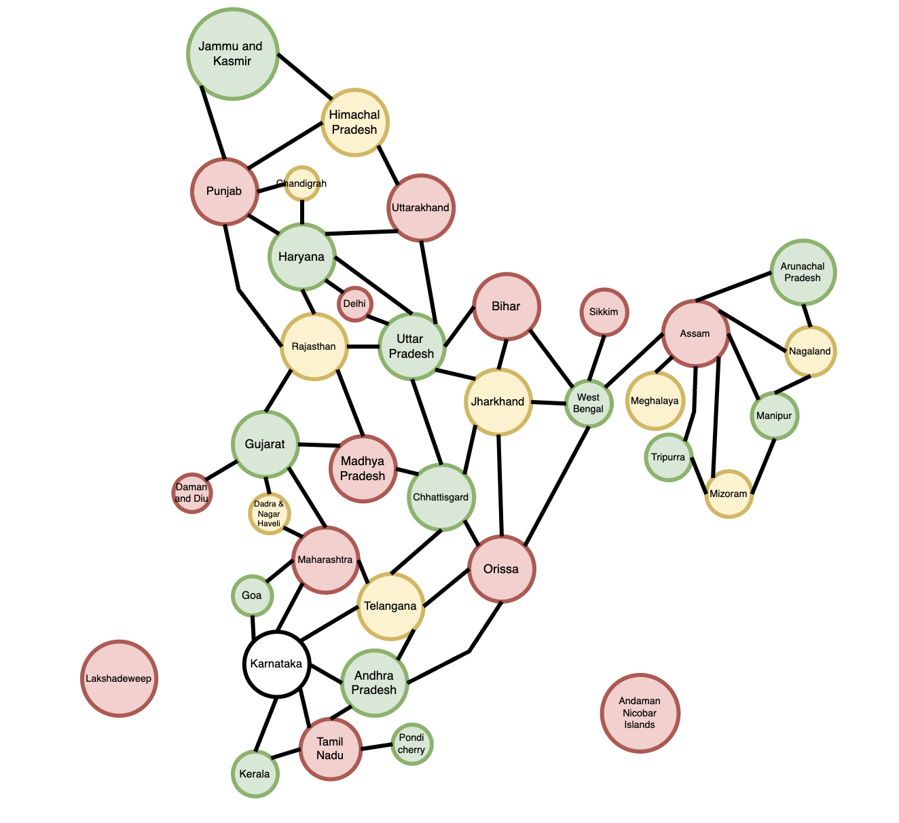

**­­­Step 4:** Eliminated the colored­ nodes, we can see that almost the nodes are colored that didn’t conflict with the colors of its neighbor. We use the final color is blue to Color the Karnataka.

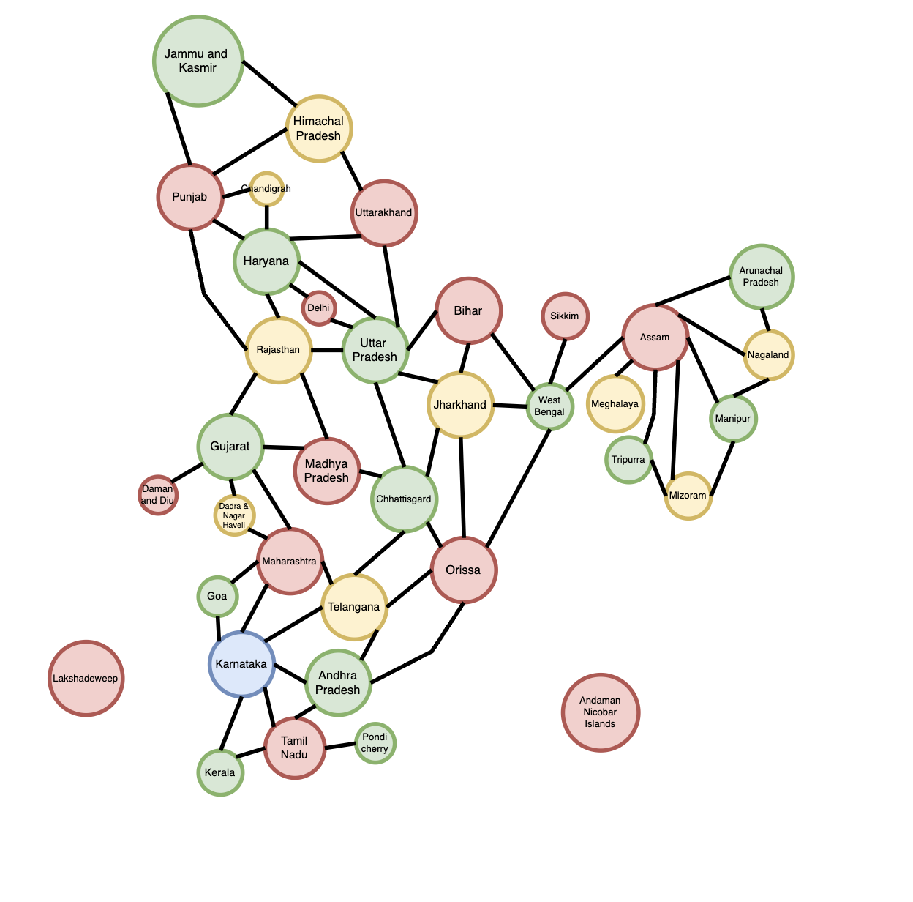

**Summarize:** We used 4 colors to color the map, we have:

**#1Red**: (Bihar, Sikkim, Assam, Uttarakhand, Delhi, Punjab, Madhya P, Orrisa, Maharashtra, Tamil Nadu, Lakshadeweep, Andaman Nicobar)

**#2Green**: (J and K, Haryana, Uttar P, West Bengal, Tripurra, Manipur, Arunachal P, Gujarat, Chhattisgrad, Goa, An­­dhra P, Pondicherry, Kerala )

**#3Yellow**: (Himachal P, Chadigarh, Rajasthan, Jharkhand, Meghalaya, Nagaland, Mizoram, Dadra and Nagar Haveli, Tenlagana)

**#4Blue**: (Karmataka)­